

BIOMOLECULES

Topic-1: Carbohydrate (Part-1)

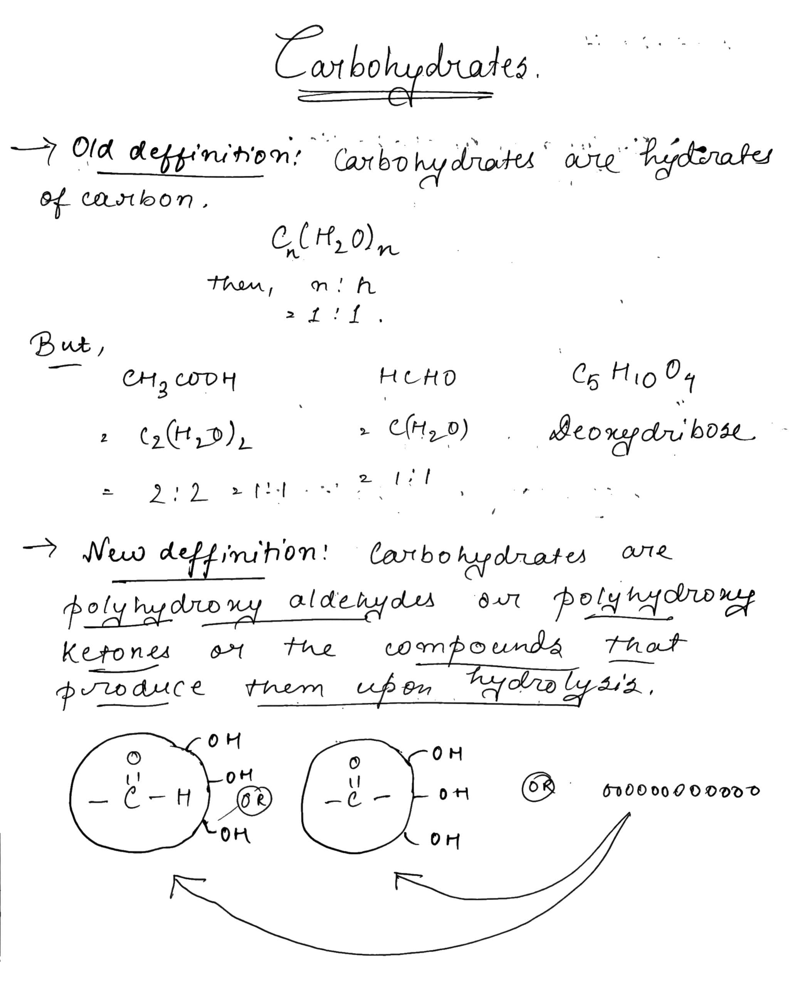

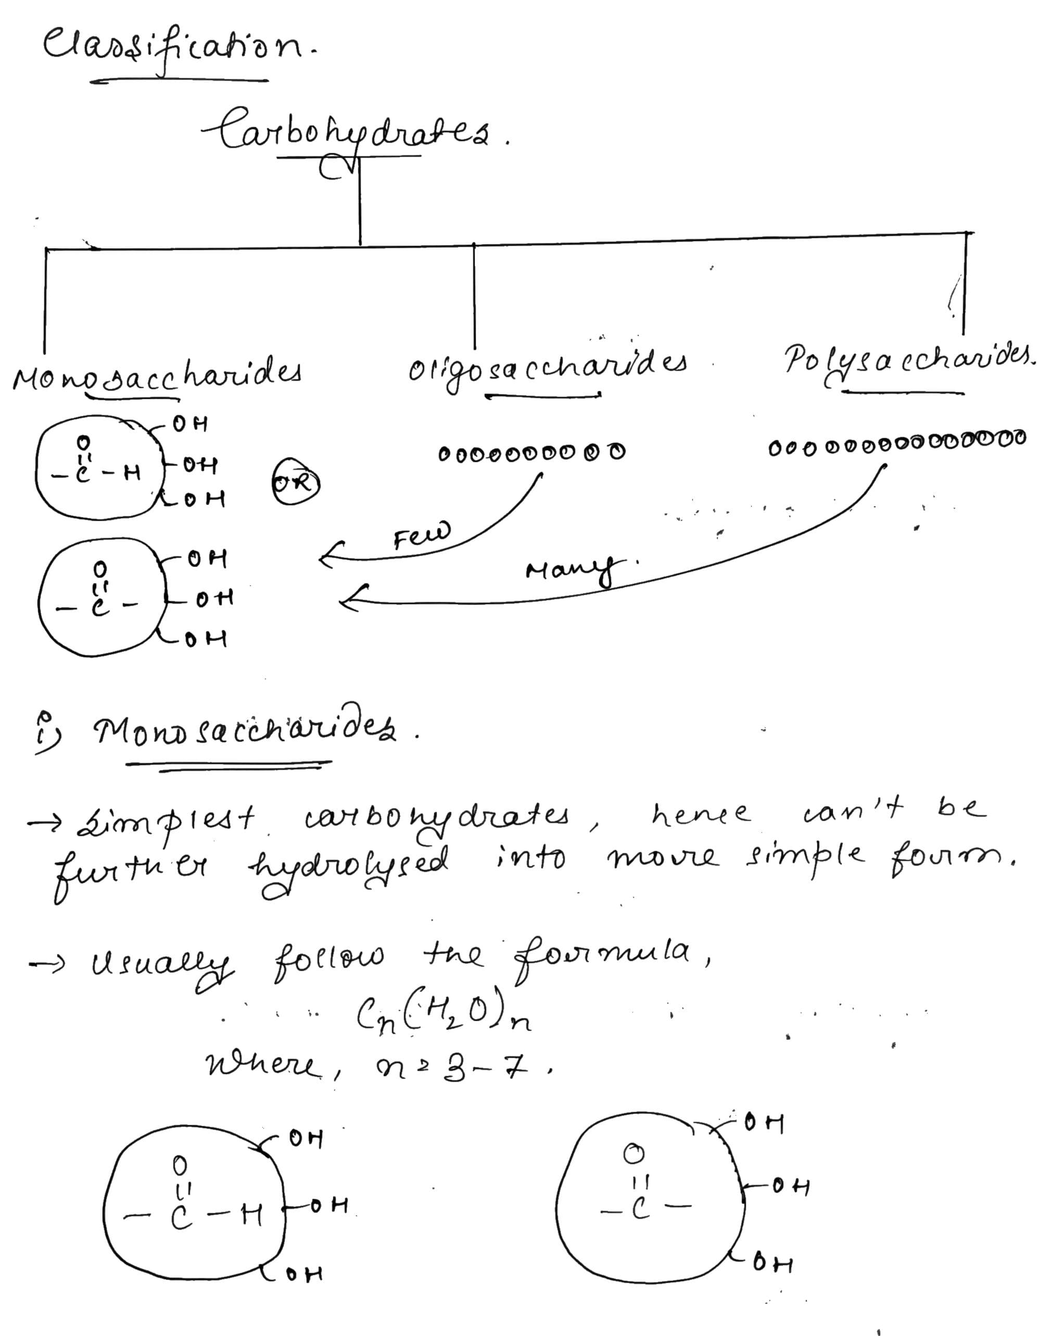

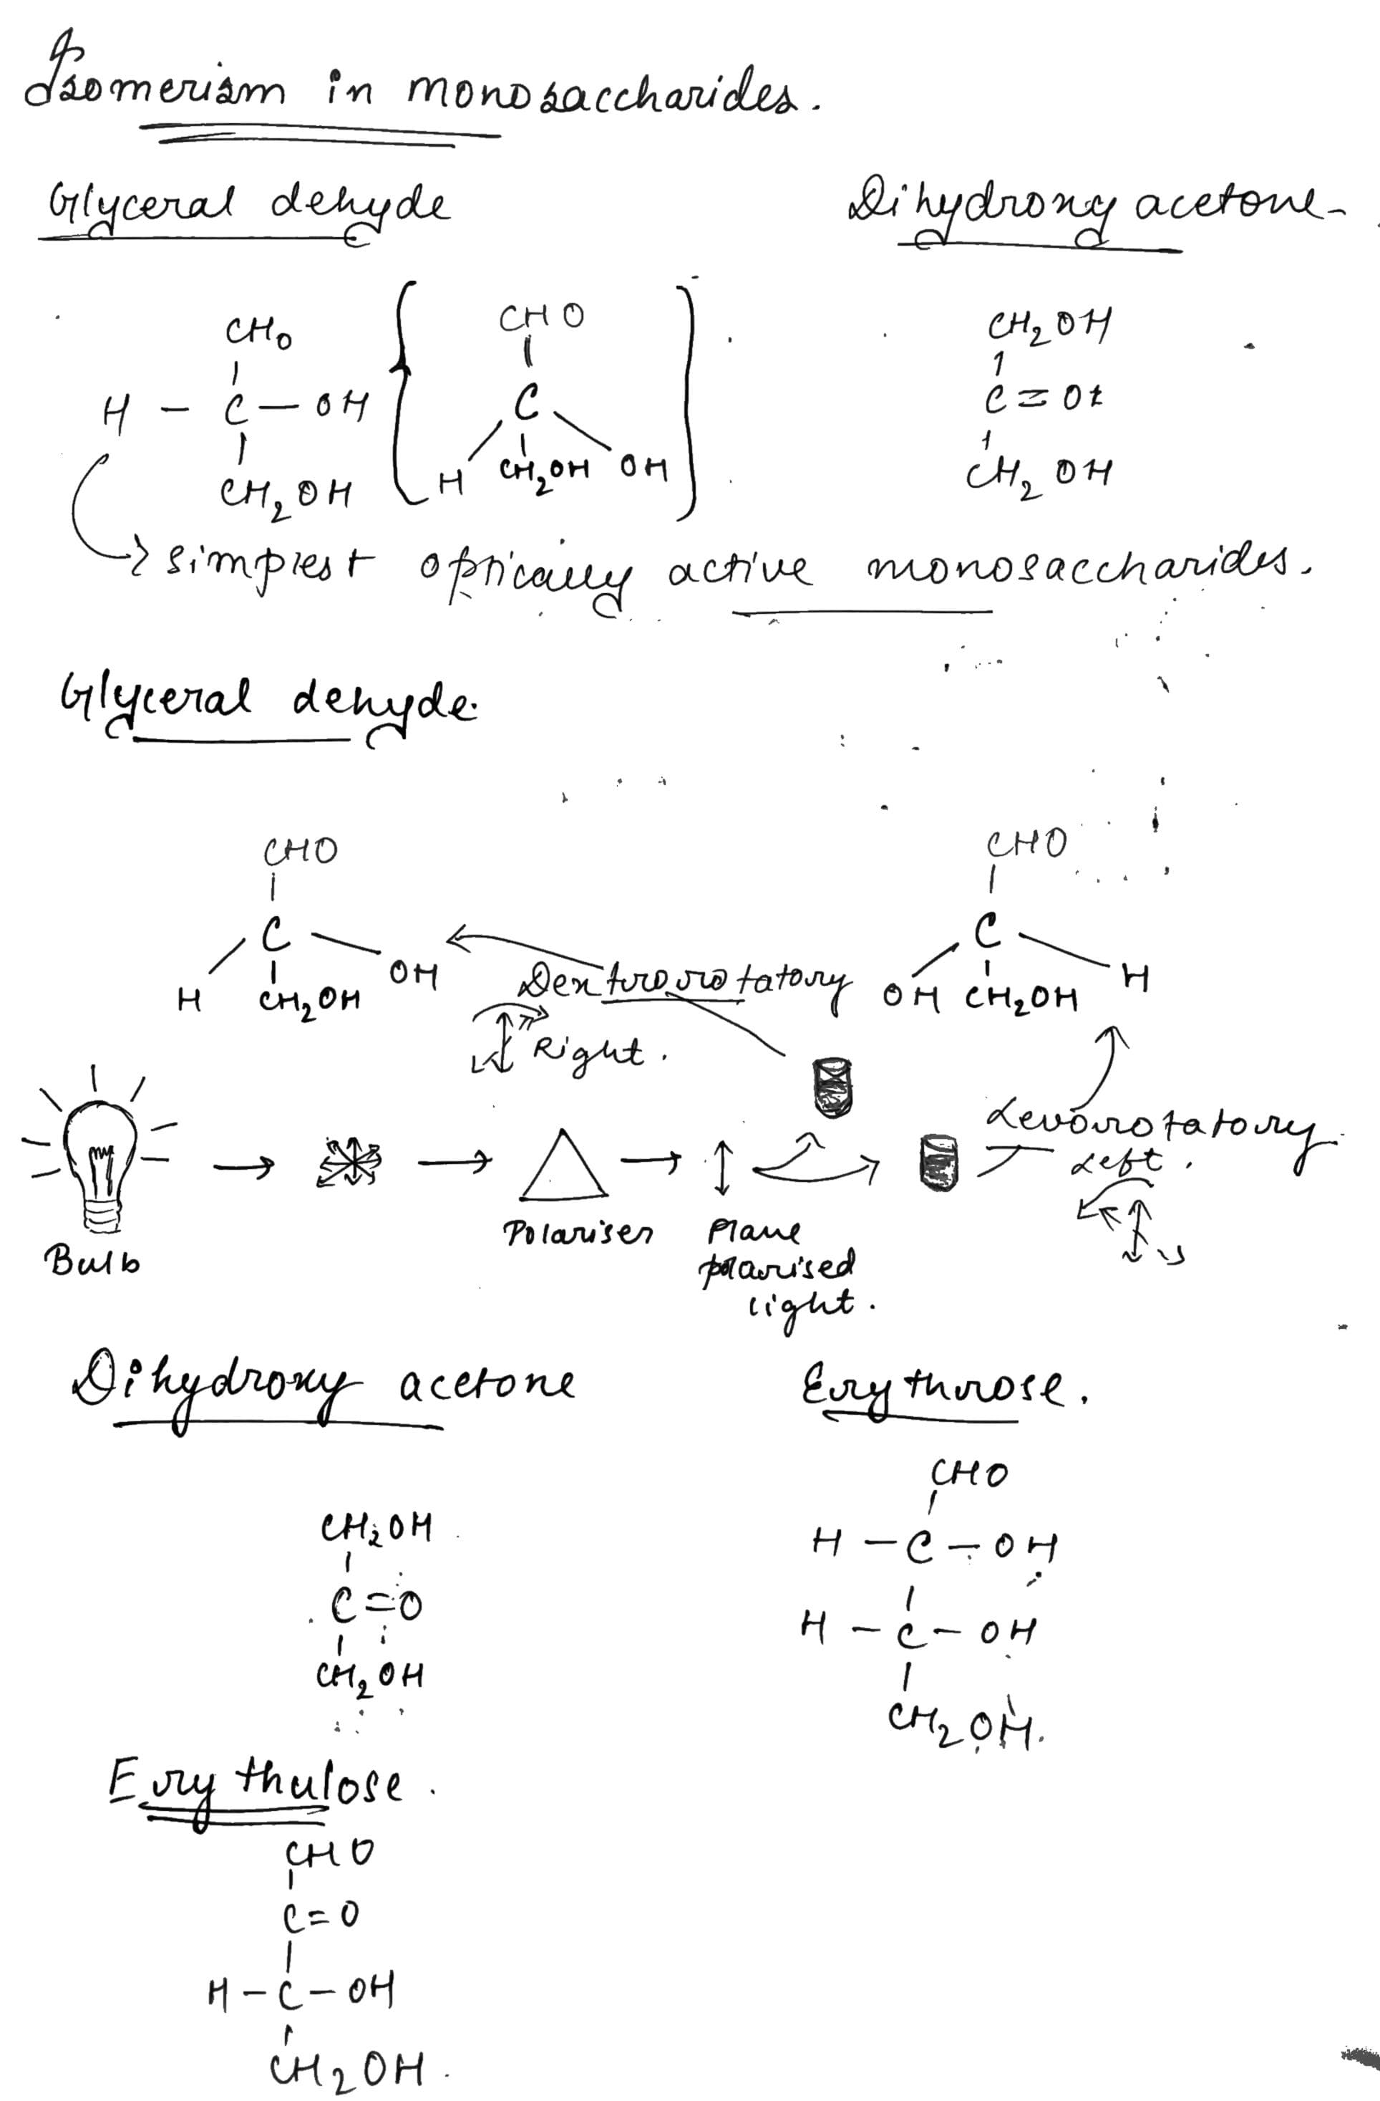Classification:

On the basis of functional groups

|  |  |  |
| --- | --- | --- |
| **CLASSES** | **Aldoses (CHO)** | **Ketoses (CO)** |
| **Trioses (3C)** | Glycerol dehyde | Dihydroxy acetone |
| **Tetroses (4C)** | Erythrose | Erythrulose |
| **Pentoses (5C)** | Ribose | Ribulose |
| **Hexoses (6C)** | Glucose, Mannose, Galactose | Fructose |
| **Heptoses (7C)** | Glucoheptose | Seduheptose |

